

**ISSUE 16: Monday 6th June – Sunday 12th June**

THE BRUCE BILLITIN

*Doing it for Bill since 2014*

*Doing it for Bill since 2014*

He was deep into the exam period and had no clear way out. Schmidtiana Jones was hopelessly lost and he knew it. All he could see for miles were discarded memes, dreams and people making scenes. It was a trap and he was finding it harder to work his way out of the slowly piling stress and sudden weight gain from excessive lolly cups. Of course! The Marks he’d lost over the semester were the problem, if only he could find them, then maybe he could use them to get out of this mess. But where to look…..

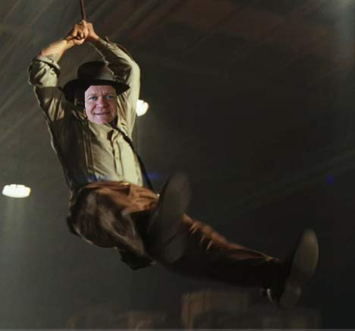

THE TEMPLE OF DOOM

National Capital Authority

Everything is silent as you step up the avenue, apart from the occasional tweeting of a student. Schmidtiana’s photo is immediately uploaded to stalkerspace with a relevant and jokey caption, but he does not know that he is being watched. Nonetheless he treads lightly, hoping to avoid any traps..

ANU/THE CANBERRA TIMES: Meet the author event with Ian Lowe MCT2  
**7th June 6-7pm**

Ian Lowe is a prize winning author, receiver of the Eureka prize, and the Prime Minister’s Award in environment & Science. Surely he might know something in this intriguing event in which he discusses the motivation behind his book ‘The Lucky Country? Reinventing Australia’.

US CLIMATE POLICY: What happens when Obama’s gone?  
**5:30-6:45pm 8th June JG Crawford Building**

What will happen when Obama’s gone? Schmidtiana might need to go back to America to get a new framed photo with the new president. Find out in this presentation!

THE GREAT SARCOPHAGUS

Canberra is a place full of hidden treasures, buried away between slogans and public art. Maybe at these events he could find the marks, and catch the raiders who stole them…

HANDMADE MARKET JUNE 2016

**11th-12th June 10-4pm Exhibition Park**

Hmmmm, everything seems to be made by hand at this award-winning market, with food, artists and designers all under one roof. I’ve counted over 220 stalls, but no marks. While worth a visit, I might have to look elsewhere….

CAPITAL JAZZ PROJECT  
**8th-13th June Various times Street Theatre**

What’s this? Cabaret Jazz? Red Lighting? Crooning singers? Sounds just like the place some wannabe raiders would be with my lost marks. However in his rush, Schmidtiana failed to see all the leading musicians as he didn’t check out the times on the website (<http://www.thestreet.org.au/whats/festivals/capital-jazz-project>). They should have put them on wattle!

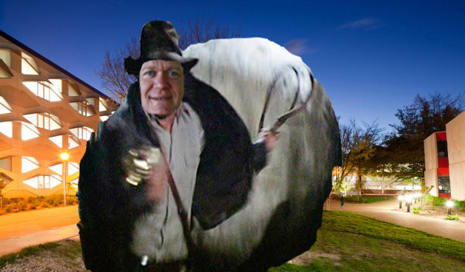

*You’re going to get killed chasing after your damn fortune and glory!* – Billie Scot



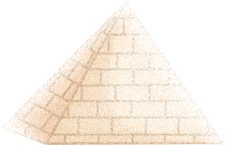

SCHMIDTIANA JONES AND THE RAIDERS OF THE LOST MARKS

**After arriving at ANU, Schmidtiana Jones sets off through the campus on the hunt for his lost marks and the raiders who took them. However, he needs advice to find them, where do you think he should go first to start his research; Chifley or Hancock?**



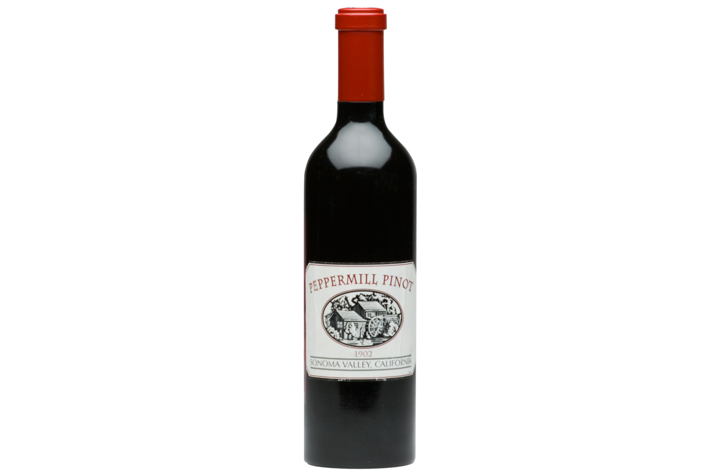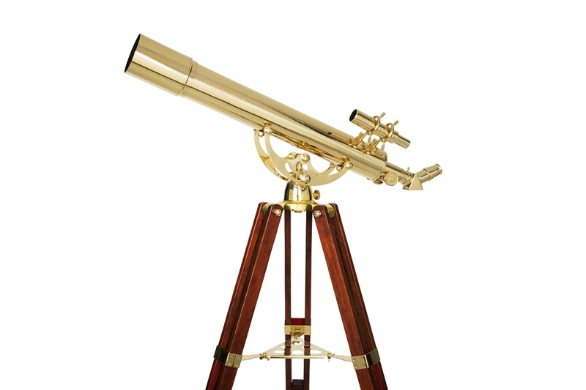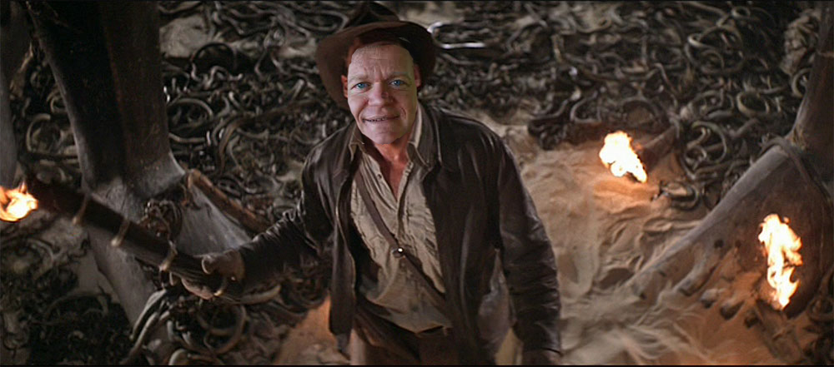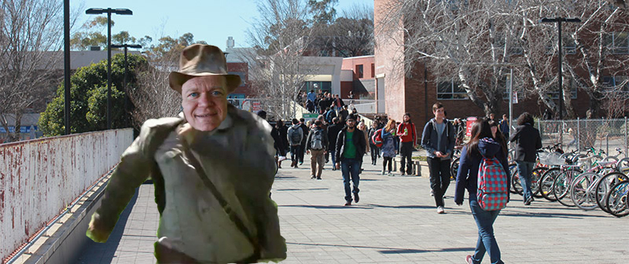

1.Invictus, 2.Lufthansa, 3. Lasagna 4.Ukraine, 5. Manhattan, 6. Iodine, 7. Neuschwanstein Castle, 8. Anne Boleyn, 9. Trafalgar, 10. Isosceles

TRIVIA

1. In what 2009 film did Morgan Freeman play Nelson Mandela? 7. What castle was the main architectural inspiration

2. What is the name of Germany’s national airline? for the sleeping beauty castle in Disneyland California?

3. What pasta dish is Garfield the cat’s favourite dish? 8. Who was Henry VIII’s second wife?

4. In what country is the Chernobyl power plant located? 9. Horatio Nelson was fatally wounded at what 1805 battle?

5. Whiskey, sweet vermouth and bitters make what cocktail, often 10. What is the name given to a triangle with two sides  
garnished with a cherry? of equal length?

6. Which chemical element gets its name from the Greek for ‘violet’?

You have chosen poorly. After waxing a bit too lyrical, you get chased out by a mob of angry students waving their puffer jackets and fancy water bottles

From the info he realises that he needs to go to the Vice Chancellery, his own home. Upon his arrival he walks up to the front desk, sweat dripping from his brow and hands over the info. Based off the info he suspects that it is the same culprit this time as it was last time, and so he demands the culprit reveals himself, or cunning Schmidtiana would reveal to all the latest in office gossip. The stuttering receptionist hands him a note. The raider of the lost marks name is hidden in the answers to the Trivia quiz written on it….

At the law office you find a bereaved student sitting there clutching the info. He’d brought it into the exam thinking it was a useful case. Schmidtiana coaxes it away from the poor creature, and examines it …..

The info is not at Woroni, but they won’t let Schmidtiana leave, thinking this might be the biggest story they’ve ever had! They throw him into the pit with all the local Stupol hacks.

You have chosen wisely, with Chifley’s lack of noise and surplus of seating. Looking through its dusty archives, Schmidtiana finds out that a student has ripped out a page in an old tome containing info as to the last case of stolen marks. Where do you go to find the offending student, Woroni, or the Law building?